**ECE 637 Lab1 Report**

**Ruijie Song**

**Jan. 29. 2021**

**Section 3 Report:1.**

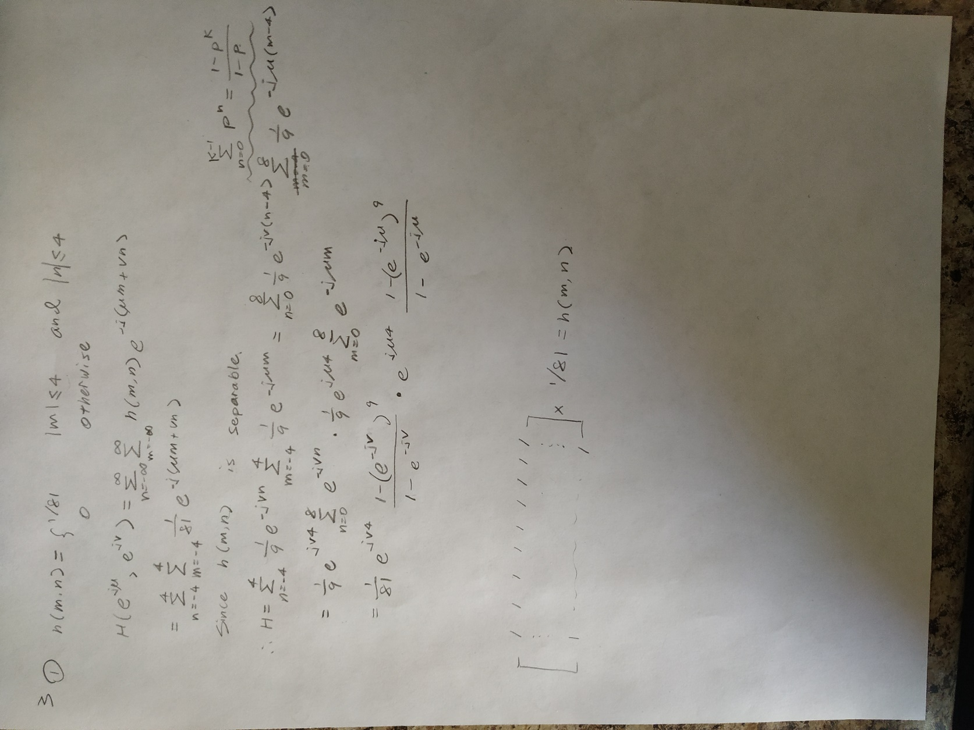

Figure 1. A derivation of the analytical expression for H

**2.**

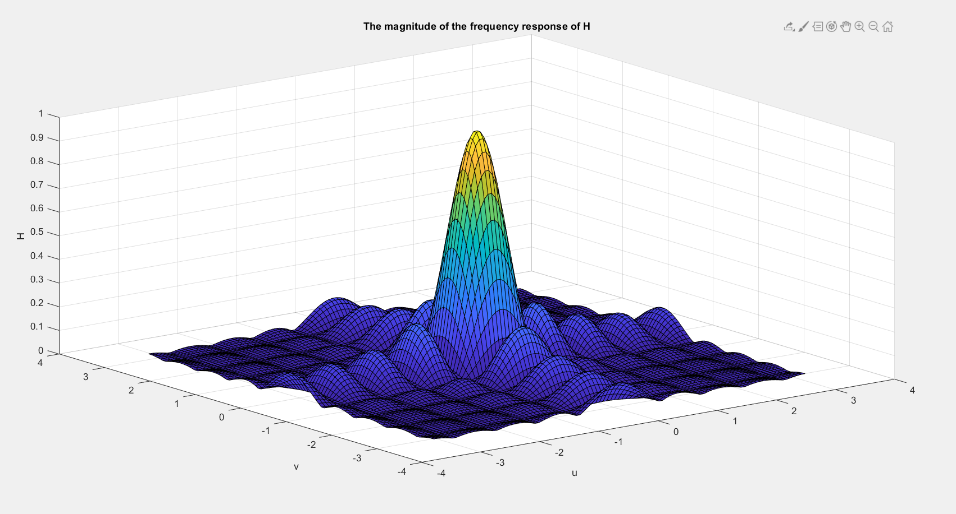

Figure 2. A plot of |H|

**3.**



Figure 3. img03.tif Figure 4. color.tif



Figure 5. green.tif

**4.**



Figure 6. The filtered color image

**Section 4 Report:**

1. **& 2.**

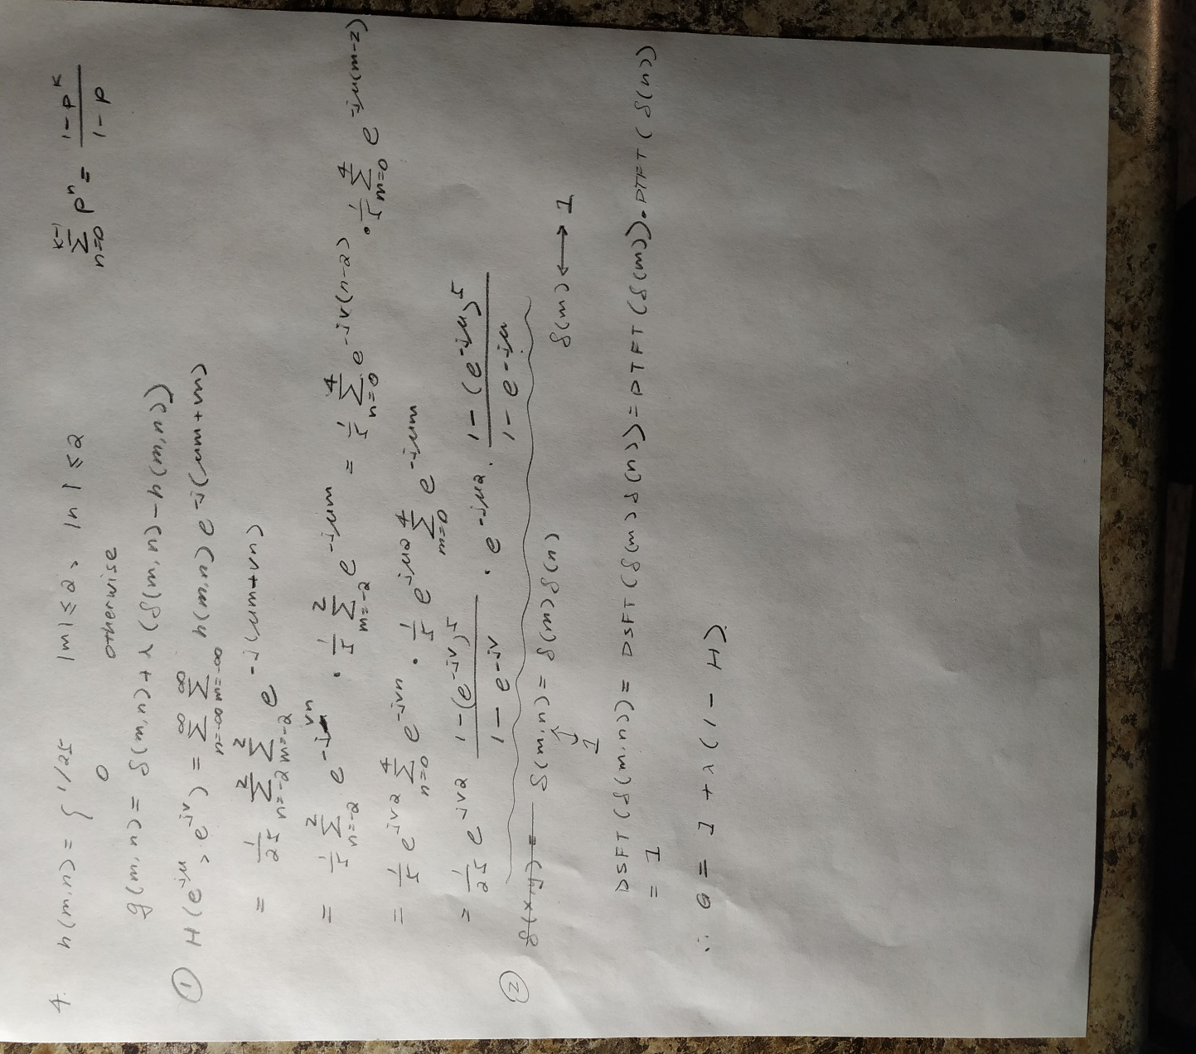

Figure 7. A derivation of the analytical expression for H & G

**3.**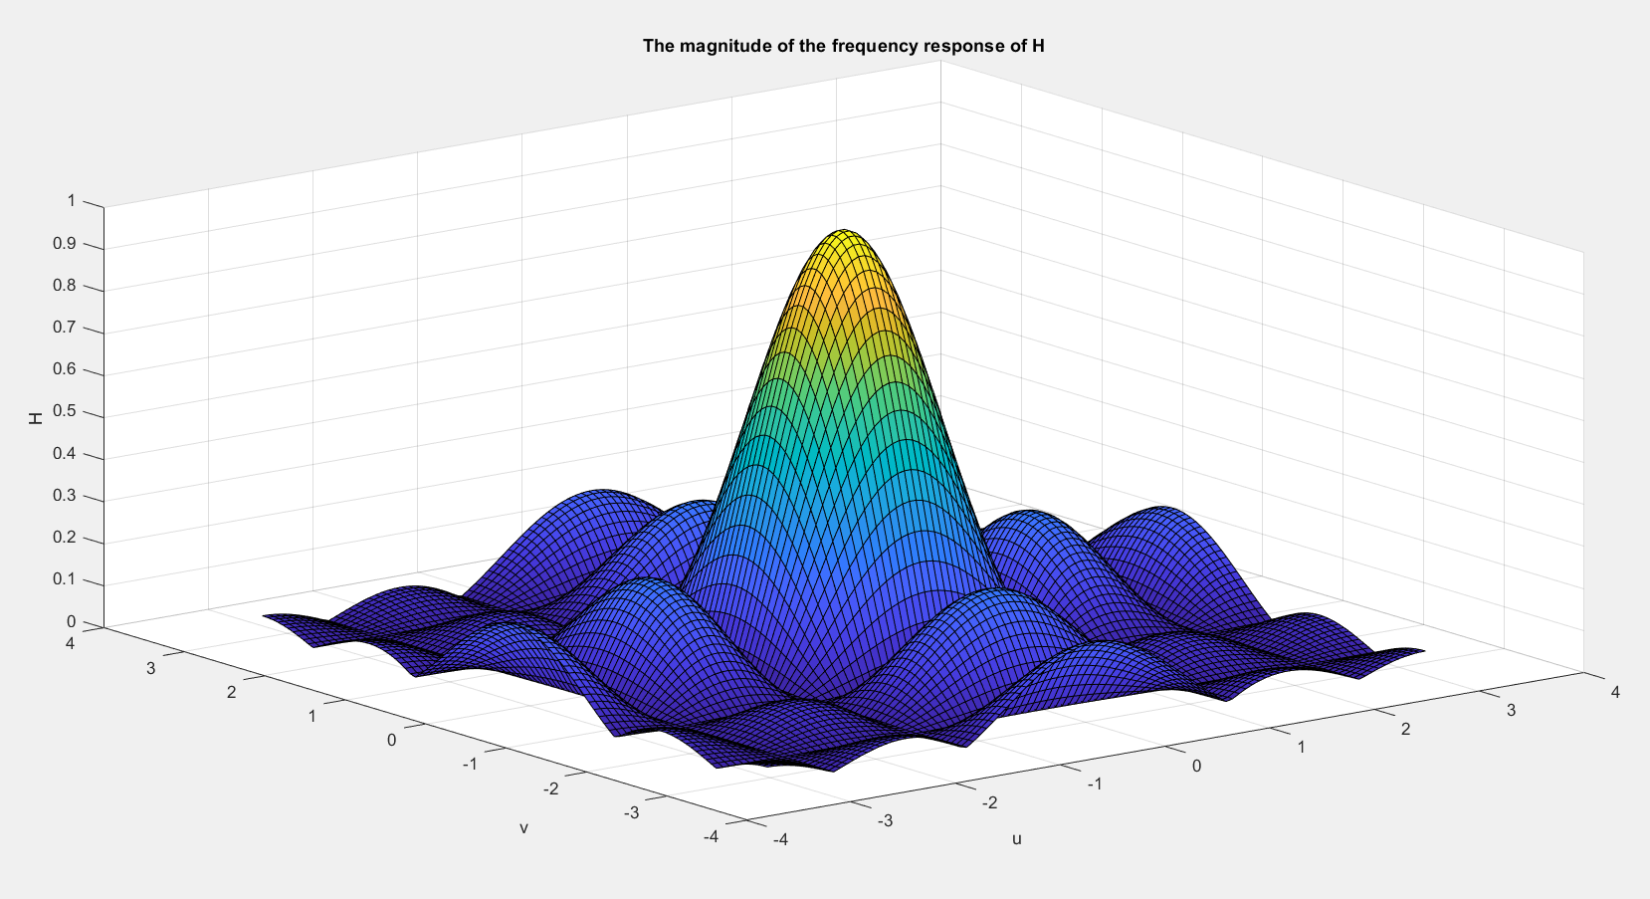

Figure 8. A plot of |H|

4.

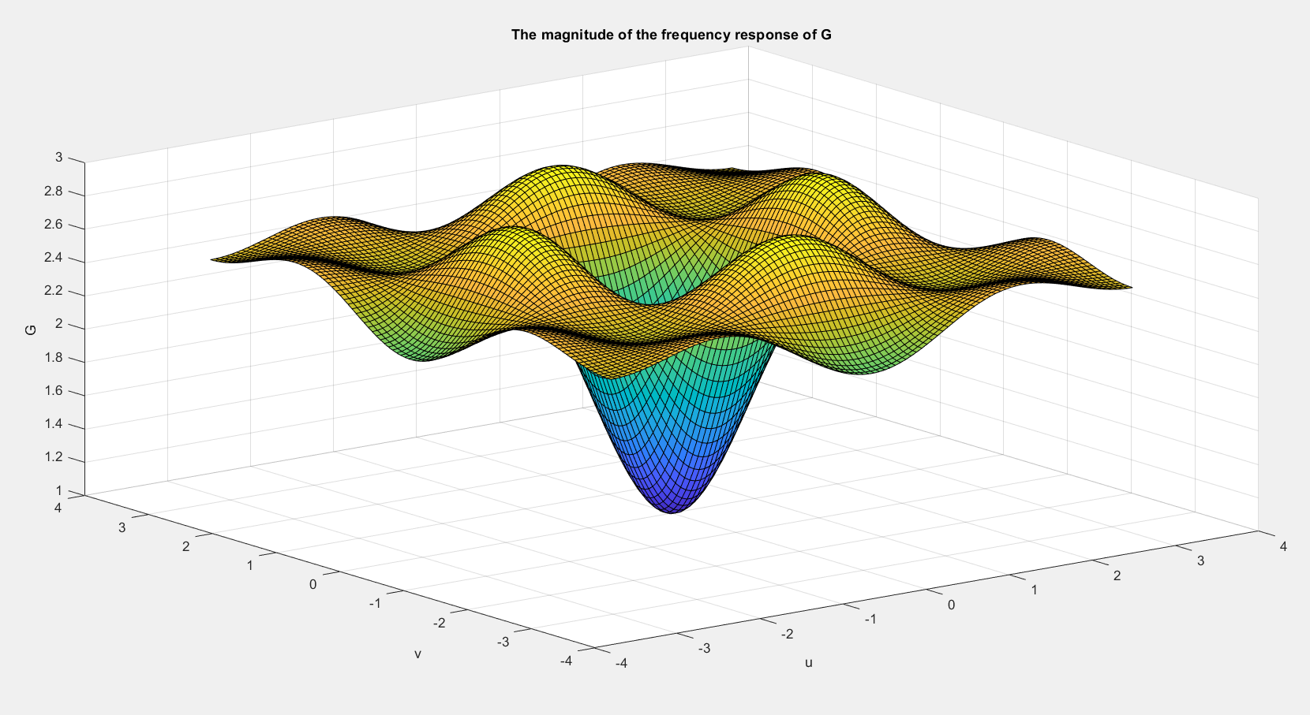

Figure 9. A plot of |G|

5.



Figure 10. imgblur.tif.

6.



Figure 11. The output sharpened color image for λ = 1.5

5. IIR Filter

1.

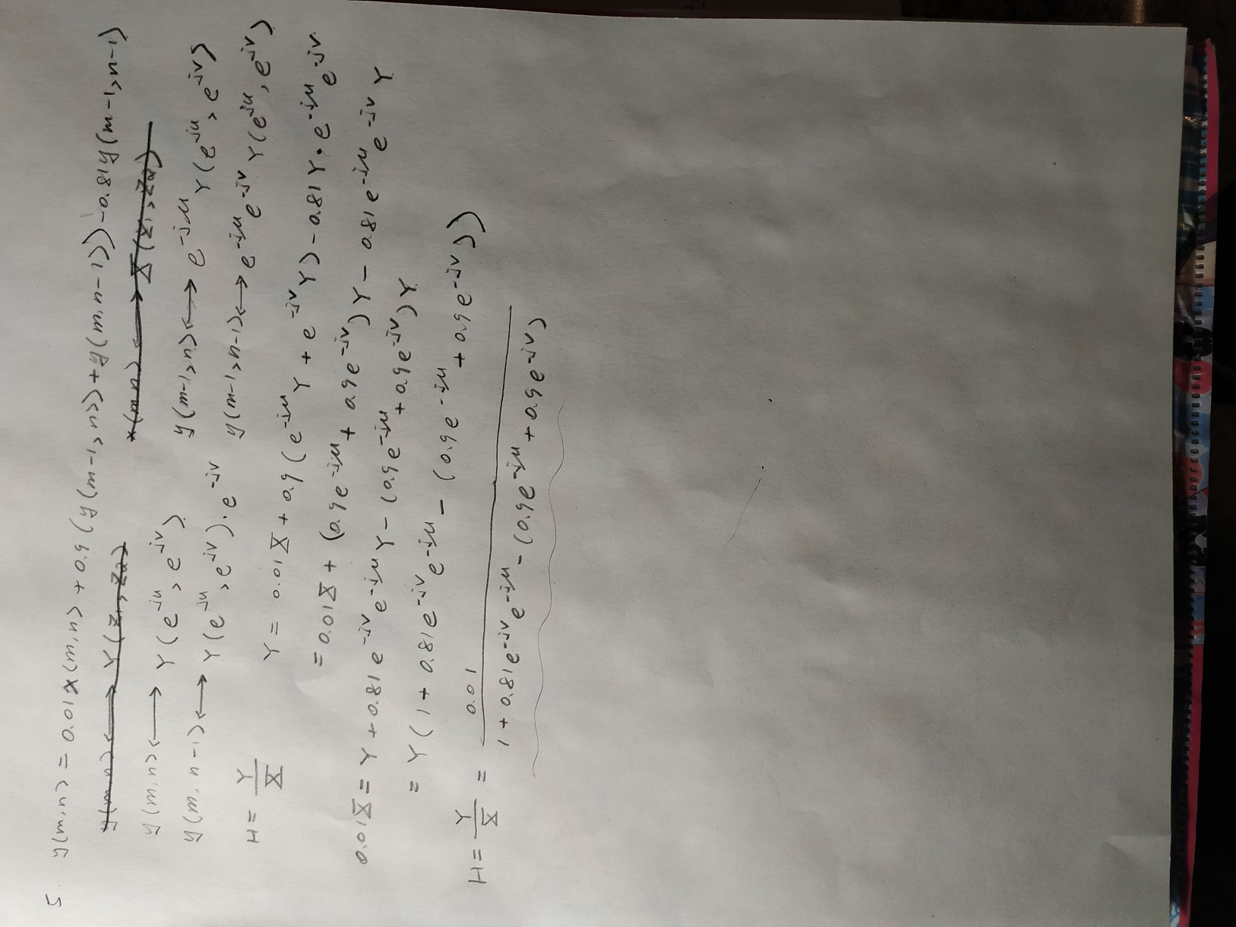

Figure 12. A derivation of the analytical expression for H

2.

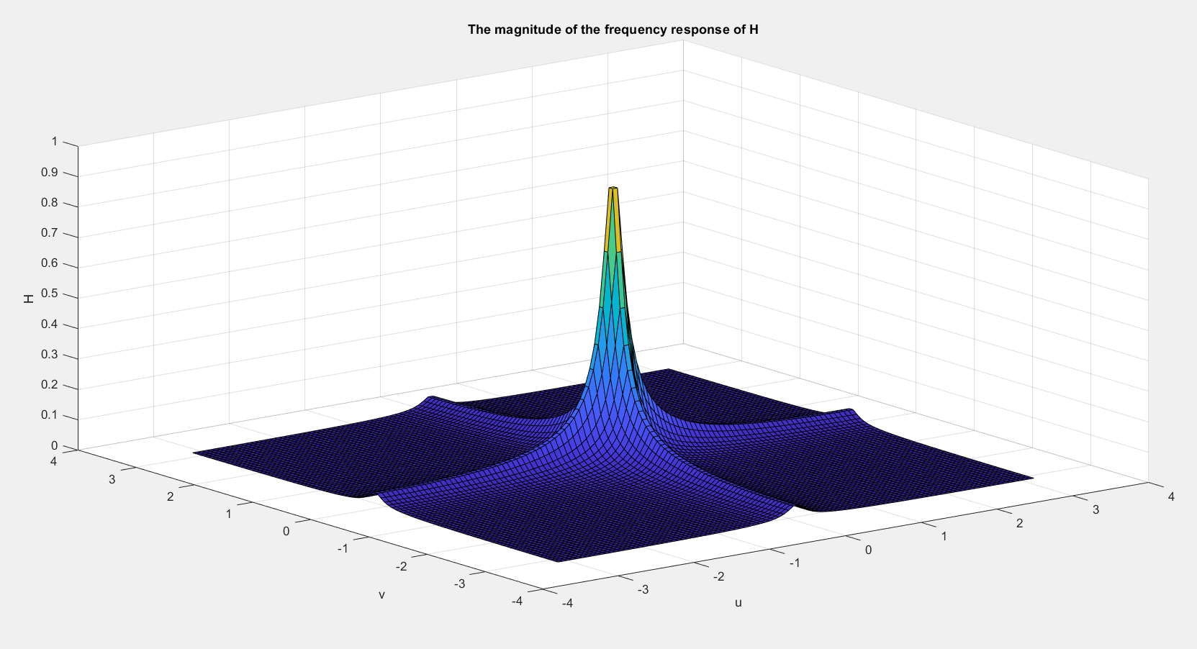

Figure 13. A plot of |H|

3.



Figure 14. An image of the point spread function

4.



Figure 15. The filtered output color image.